**Model Development Phase Template**

|  |  |
| --- | --- |
| Date | 18 June 2025 |
| Team ID | SWTID1749631993 |
| Project Title | Restaurant Recommendation System |
| Maximum Marks | 4 Marks |

**Initial Model Training Code, Model Validation and Evaluation Report:**

The initial model training code will be showcased in the future through a screenshot. The model validation and evaluation report will include classification reports, accuracy, and confusion matrices for multiple models, presented through respective screenshots.

**Initial Model Training Code:**

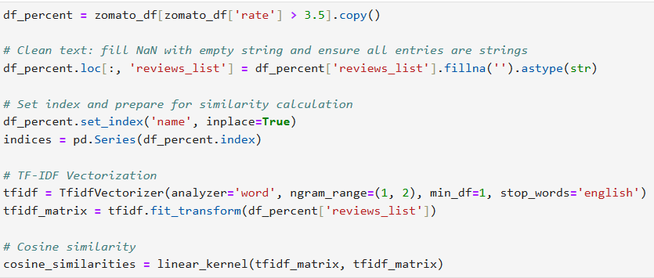

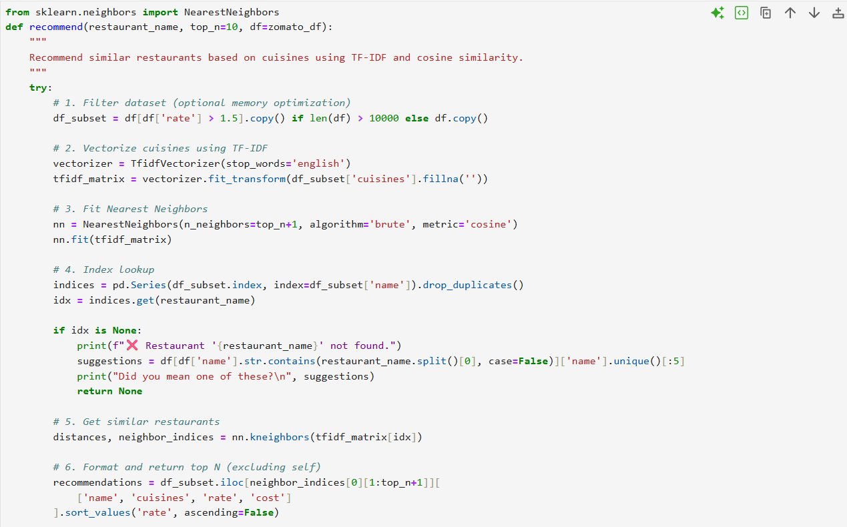

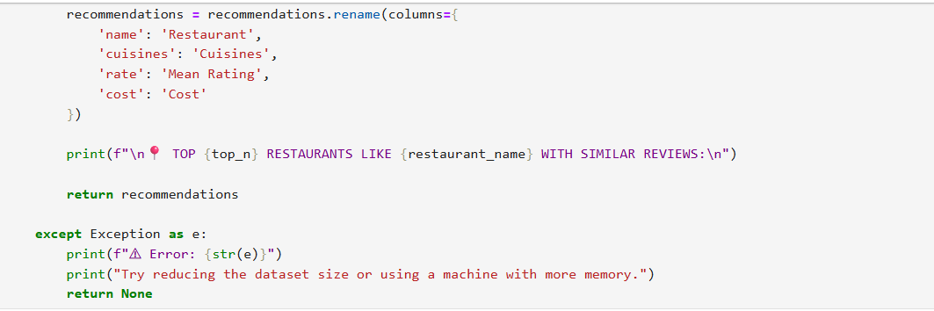

**Model Validation and Evaluation Report:**

|  |  |  |  |
| --- | --- | --- | --- |
| **Model** | **Classification Report** | **Accuracy** | **Confusion Matrix** |
| TF-IDF vectorization | - | - | - |
| Recommendation System using TF-IDF and Nearest Neighbors | - | - | - |

**Since our system uses unsupervised recommendation based on TF-IDF and cosine similarity, traditional evaluation metrics like classification accuracy or confusion matrix do not apply**